**Exercise 1: Logging Error Messages and Warning Levels**

Write a Java application that demonstrates logging error messages and warning levels using SLF4J.

Added dependency

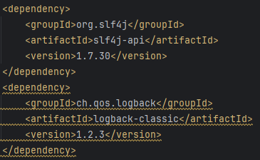

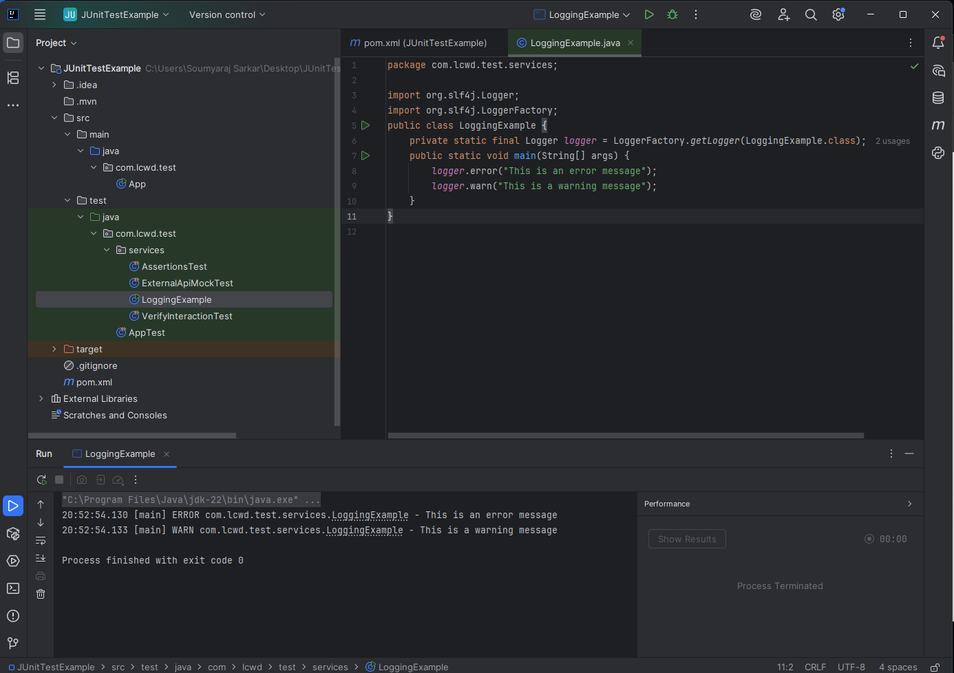Create a Java class that uses SLF4J for logging with Output: